CE100 Algorithms and Programming II

Heap/Heap Sort

Author: Asst. Prof. Dr. Uğur CORUH

## CE100 Algorithms and Programming II

## Week-4 (Heap/Heap Sort)

#### Spring Semester, 2021-2022

Download [DOC](ce100-week-4-heap.tr.md_doc.pdf), [SLIDE](ce100-week-4-heap.tr.md_slide.pdf), [PPTX](ce100-week-4-heap.tr.md_slide.pptx)

## Heap/Heap Sort

## Outline (1)

* Heaps
  + Max / Min Heap
* Heap Data Structure
  + Heapify
    - Iterative
    - Recursive

## Outline (2)

* Extract-Max
* Build Heap

## Outline (3)

* Heap Sort
* Priority Queues
* Linked Lists
* Radix Sort
* Counting Sort

## Heapsort

* Worst-case runtime: $O\left(nlgn\right)$
* Sorts in-place
* Uses a special data structure (heap) to manage information during execution of the algorithm
  + Another design paradigm

## Heap Data Structure (1)

* Nearly complete binary tree
  + Completely filled on all levels except possibly the lowest level

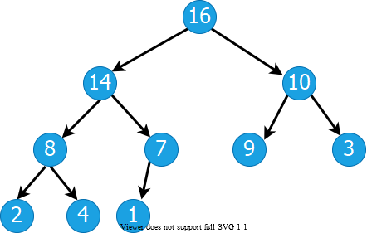

alt:“alt” height:350px center

## Heap Data Structure (2)

* **Height of node i:** Length of the longest simple downward path from **i** to a **leaf**
* **Height of the tree:** height of the **root**

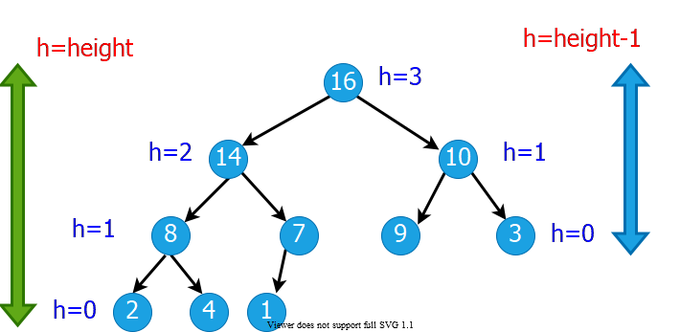

alt:“alt” height:400px center

## Heap Data Structures (3)

* **Depth of node i:** Length of the simple downward path from the **root** to node **i**

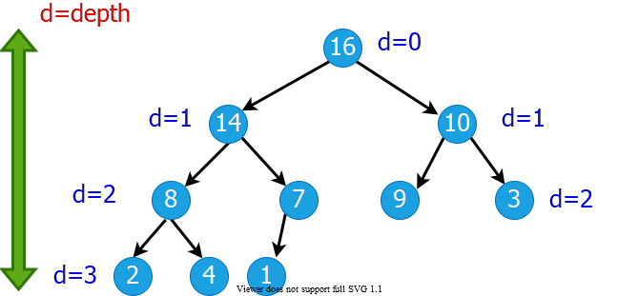

alt:“alt” height:350px center

## Heap Property: Min-Heap

* The **smallest** element in any subtree is the **root** element in a **min-heap**
* **Min heap:** For every node **i** other than **root**, $A\left[parent\left(i\right)\right]≤A\left[i\right]$
  + Parent node is always smaller than the child nodes

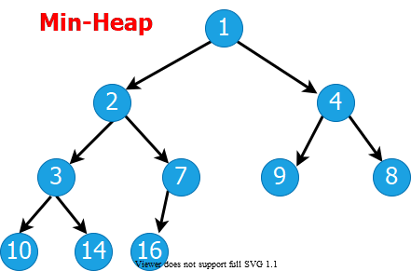

bg right:40% w:480

## Heap Property: Max-Heap

* The **largest** element in any subtree is the **root** element in a **max-heap**
  + We will focus on max-heaps
* **Max heap:** For every node **i** other than **root**, $A\left[parent\left(i\right)\right]≥A\left[i\right]$
  + Parent node is always larger than the child nodes

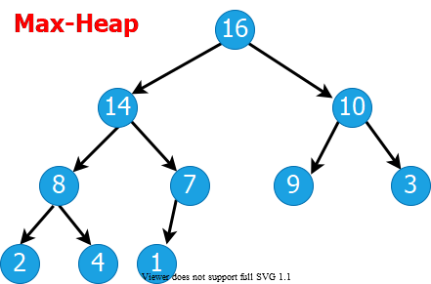

bg right:40% w:480

## Heap Data Structures (4)

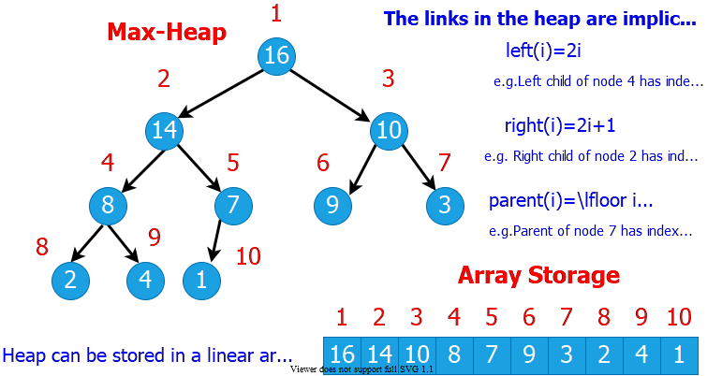

alt:“alt” height:500px center

## Heap Data Structures (5)

* Computing left child, right child, and parent indices very fast
  + **left(i) = 2i $⇒$** binary left shift
  + **right(i) = 2i+1 $⇒$** binary left shift, then set the lowest bit to 1
  + **parent(i) = floor(i/2) $⇒$** right shift in binary
* $A\left[1\right]$ is always the **root** element
* Array $A$ has two attributes:
  + **length(A):** The number of elements in $A$
  + **n = heap-size(A):** The number elements in $heap$

$n≤length\left(A\right)$

## Heap Operations : EXTRACT-MAX (1)

EXTRACT-MAX(A, n)  
 max = A[1]  
 A[1] = A[n]  
 n = n - 1  
 HEAPIFY(A, 1,n)  
 return max

## Heap Operations : EXTRACT-MAX (2)

* Return the max element,and reorganize the heap to maintain heap property

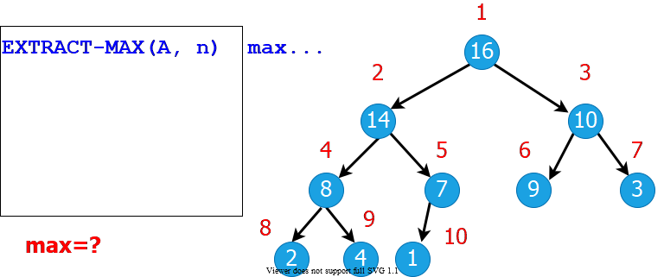

alt:“alt” height:400px center

## Heap Operations: HEAPIFY (1)

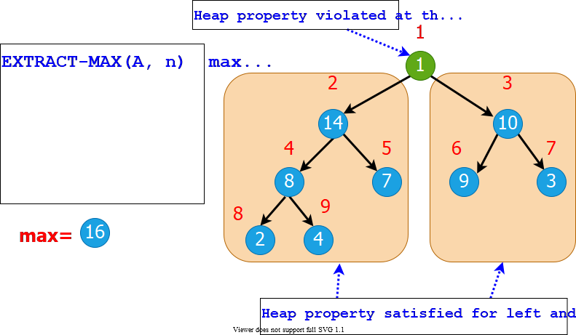

alt:“alt” height:500px center

## Heap Operations: HEAPIFY (2)

* Maintaining heap property:
  + Subtrees rooted at $left\left[i\right]$ and $right\left[i\right]$ are already heaps.
  + But, $A\left[i\right]$ may violate the heap property (i.e., may be smaller than its children)
* **Idea:** Float down the value at $A\left[i\right]$ in the heap so that subtree rooted at $i$ becomes a heap.

## Heap Operations: HEAPIFY (2)

HEAPIFY(A, i, n)  
 largest = i   
  
 if 2i <= n and A[2i] > A[i] then   
 largest = 2i;  
 endif  
  
 if 2i+1 <= n and A[2i+1] > A[largest] then   
 largest = 2i+1;  
 endif  
  
 if largest != i then  
 exchange A[i] with A[largest];  
 HEAPIFY(A, largest, n);  
 endif

## Heap Operations: HEAPIFY (3)

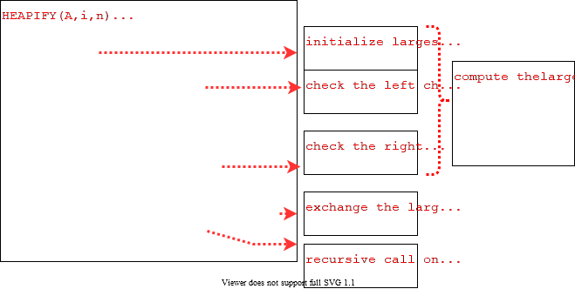

alt:“alt” height:500px center

## Heap Operations: HEAPIFY (4)

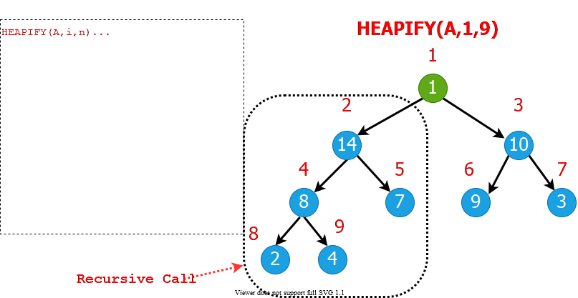

alt:“alt” height:500px center

## Heap Operations: HEAPIFY (5)

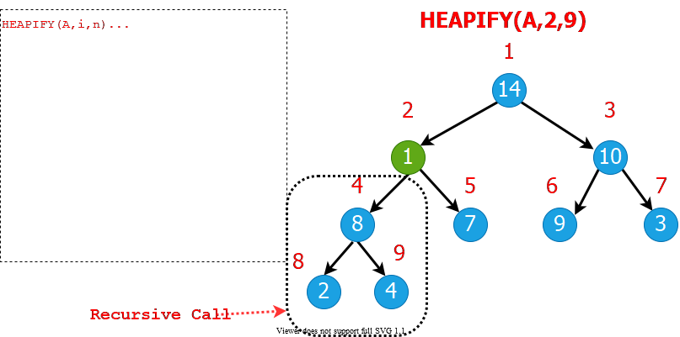

alt:“alt” height:500px center

## Heap Operations: HEAPIFY (6)

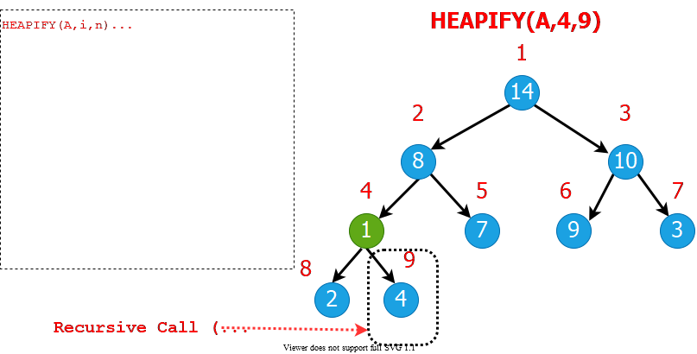

alt:“alt” height:500px center

## Heap Operations: HEAPIFY (7)

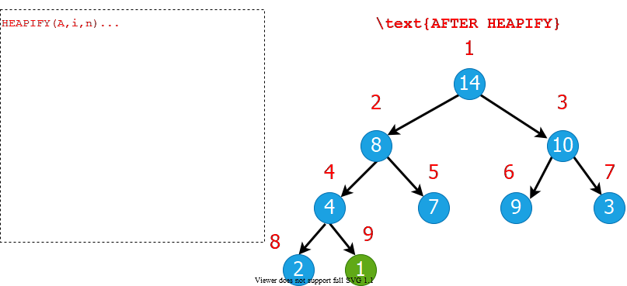

alt:“alt” height:500px center

## Heap Operations: HEAPIFY (8)

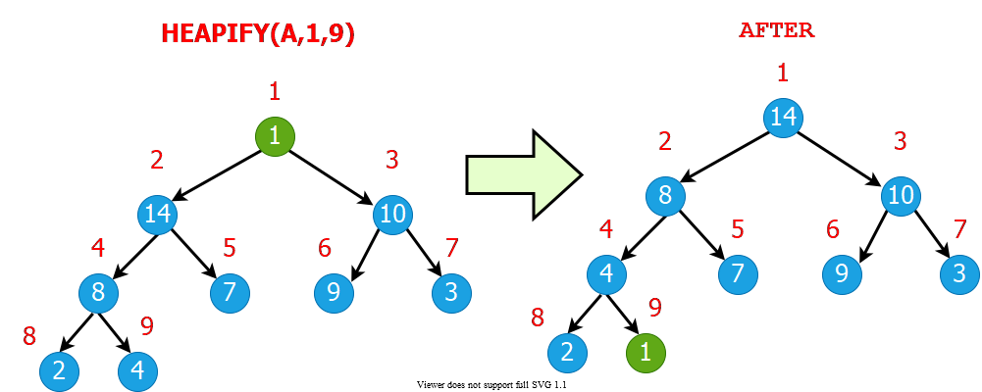

alt:“alt” height:500px center

## Intuitive Analysis of HEAPIFY

* Consider $HEAPIFY\left(A,i,n\right)$
  + let $h\left(i\right)$ be the height of node $i$
  + at most $h\left(i\right)$ recursion levels
    - Constant work at each level: $Θ\left(1\right)$
  + Therefore $T\left(i\right)=O\left(h\left(i\right)\right)$
* Heap is almost-complete binary tree
$h\left(n\right)=O\left(lgn\right)$

* Thus $T\left(n\right)=O\left(lgn\right)$

## Formal Analysis of HEAPIFY

* **What is the recurrence?**
  + Depends on the size of the **subtree** on which recursive call is made
    - In the next, we try to compute an **upper bound** for this **subtree**.

## Reminder: Binary trees

* For a complete binary tree:
  + $\#$ of nodes at depth $d$: $2^{d}$
  + $\#$ of nodes with depths less than $d$: $2^{d}−1$

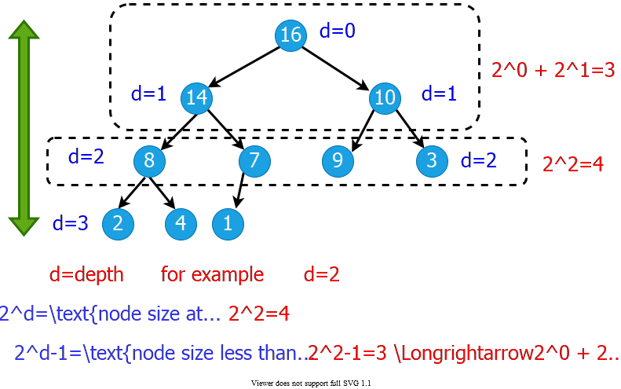

alt:“alt” height:450px center

## Formal Analysis of HEAPIFY (1)

* Worst case occurs when last row of the subtree $S_{i}$ rooted at node $i$ is **half full**
$T\left(n\right)≤T\left(\left|S_{L\left(i\right)}\right|\right)+Θ\left(1\right)$

* $S_{L\left(i\right)}$ and $S_{R\left(i\right)}$ are complete binary trees of heights $h\left(i\right)−1$ and $h\left(i\right)−2$, respectively

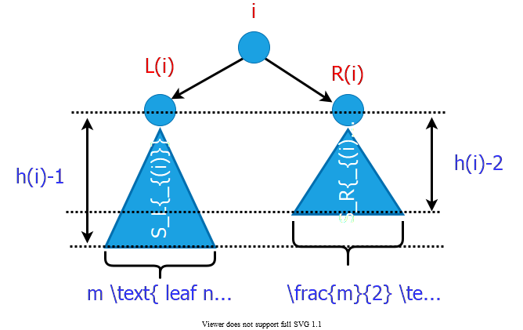

bg right:50% w:600

## Formal Analysis of HEAPIFY (2)

* Let $m$ be the number of **leaf nodes** in $S_{L\left(i\right)}$

$\left|S_{L\left(i\right)}\right|=\overset{ext.}{\overbrace{m}}+\overset{int.}{\overbrace{\left(m–1\right)}}=2m–1$

$\left|S_{R\left(i\right)}\right|=\overset{ext.}{\overbrace{\frac{m}{2}}}+\overset{int.}{\overbrace{\left(\frac{m}{2}–1\right)}}=m–1$

$\left|S_{L\left(i\right)}\right|+\left|S_{R\left(i\right)}\right|+1=n$

## Formal Analysis of HEAPIFY (2)

$$\begin{matrix}\left(2m–1\right)+\left(m–1\right)+1 & =n \\ m & =\left(n+1\right)/3 \\ \left|S_{L\left(i\right)}\right| & =2m–1 \\ & =2\left(n+1\right)/3–1 \\ & =\left(2n/3+2/3\right)–1 \\ & =\frac{2n}{3}−\frac{1}{3}≤\frac{2n}{3} \\ T\left(n\right) & ≤T\left(2n/3\right)+Θ\left(1\right) \\ T\left(n\right) & =O\left(lgn\right)\end{matrix}$$

* **By CASE-2 of Master Theorem $⇒$ $T\left(n\right)=Θ\left(n^{log_{b}^{a}}lgn\right)$**

## Formal Analysis of HEAPIFY (2)

* Recurrence: $T\left(n\right)=aT\left(n/b\right)+f\left(n\right)$
* *Case 2: $\frac{f\left(n\right)}{n^{log_{b}^{a}}}=Θ\left(1\right)$*
* i.e., $f\left(n\right)$ and $n^{log_{b}^{a}}$ grow at similar rates
* **Solution: $T\left(n\right)=Θ\left(n^{log_{b}^{a}}lgn\right)$**
  + $T\left(n\right)≤T\left(2n/3\right)+Θ\left(1\right)$ (drop constants.)

$T\left(n\right)≤Θ\left(n^{log_{3}^{1}}lgn\right)$

$T\left(n\right)≤Θ\left(n^{0}lgn\right)$

$T\left(n\right)=O\left(lgn\right)$

## HEAPIFY: Efficiency Issues

* **Recursion vs Iteration:**
  + In the absence of tail recursion, **iterative version** is in general **more efficient** because of the **pop/push** operations **to/from** stack at each **level of recursion**.

## Heap Operations: HEAPIFY (1)

**Recursive**

HEAPIFY(A, i, n)  
 largest = i   
  
 if 2i <= n and A[2i] > A[i] then   
 largest = 2i  
  
 if 2i+1 <= n and A[2i+1] > A[largest] then   
 largest = 2i+1  
  
 if largest != i then  
 exchange A[i] with A[largest]  
 HEAPIFY(A, largest, n)

## Heap Operations: HEAPIFY (2)

**Iterative**

HEAPIFY(A, i, n)  
 j = i  
 while(true) do  
 largest = j   
  
 if 2j <= n and A[2j] > A[j] then   
 largest = 2j  
  
 if 2j+1 <= n and A[2j+1] > A[largest] then   
 largest = 2j+1  
  
 if largest != j then  
 exchange A[j] with A[largest]  
 j = largest  
 else return

## Heap Operations: HEAPIFY (3)

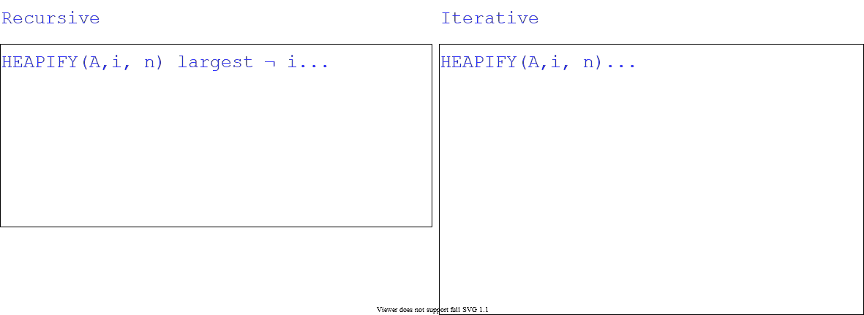

alt:“alt” height:500px center

## Heap Operations: Building Heap

* Given an arbitrary array, how to build a heap from scratch?
* **Basic idea:** Call $HEAPIFY$ on each node bottom up
  + Start from the leaves (which trivially satisfy the heap property)
  + Process nodes in bottom up order.
  + When $HEAPIFY$ is called on node $i$, the subtrees connected to the $left$ and $right$ subtrees already satisfy the heap property.
* 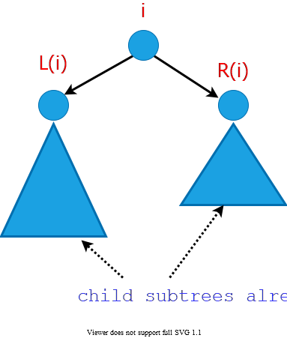
* bg right:25% w:300px

## Storage of the leaves (Lemma)

* **Lemma:** The last $⌈\frac{n}{2}⌉$ nodes of a heap are all leaves.

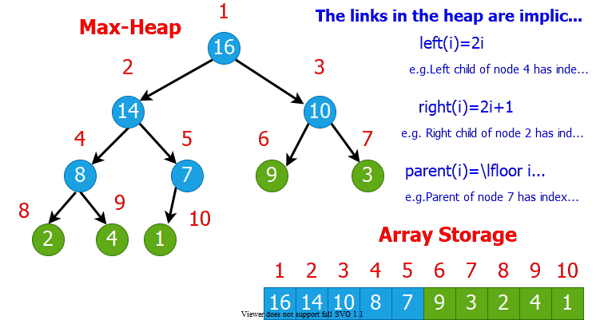

bg right:70% w:800

## Storage of the leaves (Proof of Lemma) (1)

* **Lemma:** last $⌈n/2⌉$ nodes of a heap are all leaves
* Proof :
  + $m=2^{d−1}$: $\#$ nodes at level $d−1$
  + $f$: $\#$ nodes at level $d$ (last level)
* $\#$ of nodes with depth $d−1$: $m$
* $\#$ of nodes with depth $<d−1$: $m−1$
* $\#$ of nodes with depth $d$: $f$
* **Total $\#$** of nodes : $n=f+2m−1$

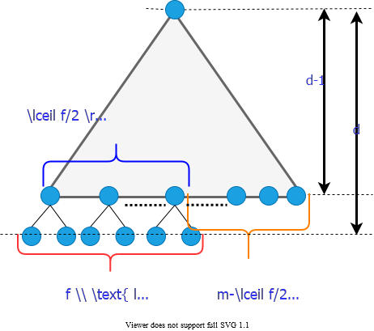

bg right:40% w:480

## Storage of the leaves (Proof of Lemma) (2)

* **Total $\#$** of nodes : $f=n−2m+1$

$$\begin{matrix}\text{\#of leaves: } & =f+m−⌈f/2⌉ \\ & =m+⌊f/2⌋ \\ & =m+⌊\left(n−2m+1\right)/2⌋ \\ & =⌊\left(n+1\right)/2⌋ \\ & =⌈n/2⌉\end{matrix}$$

Proof is Completed



bg right:40% w:480

## Heap Operations: Building Heap

BUILD-HEAP (A, n)  
 for i = ceil(n/2) downto 1 do  
 HEAPIFY(A, i, n)

* **Reminder:** The last $⌈n/2⌉$ nodes of a heap are **all leaves**, which trivially satisfy the heap property

## Build-Heap Example (Step-1)

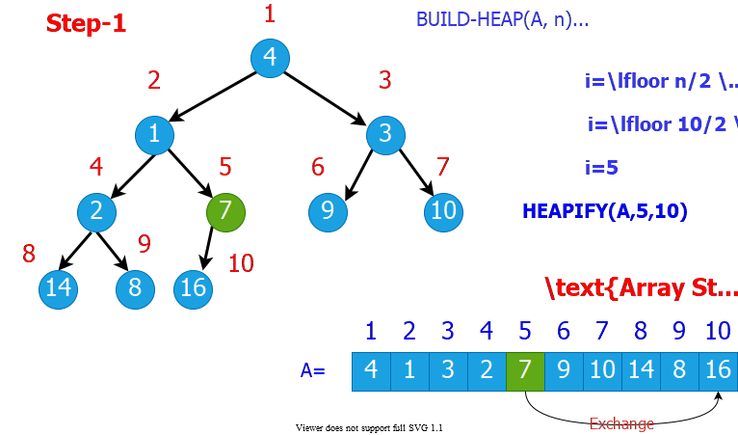

bg right:70% w:800px

## Build-Heap Example (Step-2)

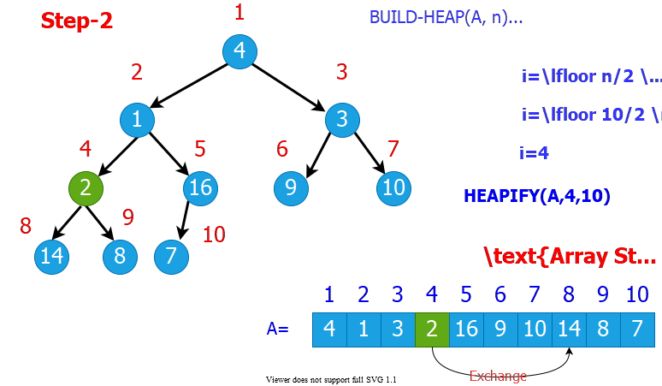

bg right:70% w:800px

## Build-Heap Example (Step-3)

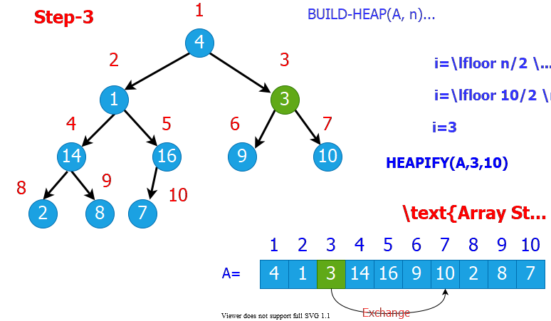

bg right:70% w:800px

## Build-Heap Example (Step-4)

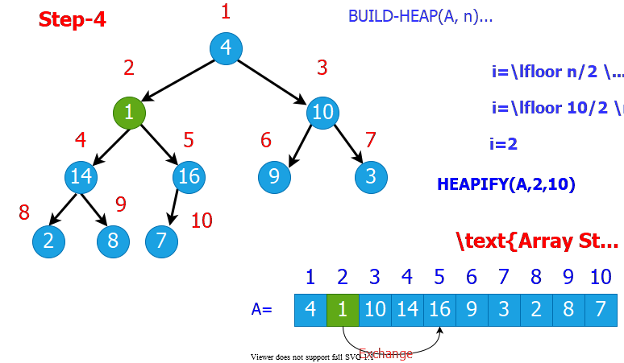

bg right:70% w:800px

## Build-Heap Example (Step-5)

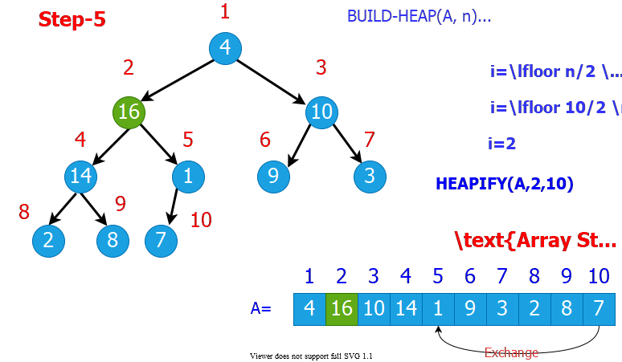

bg right:70% w:800px

## Build-Heap Example (Step-6)

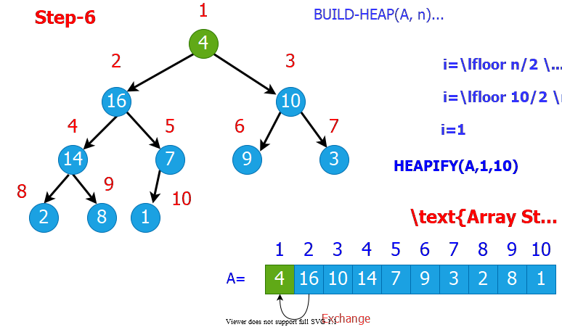

bg right:70% w:800px

## Build-Heap Example (Step-7)

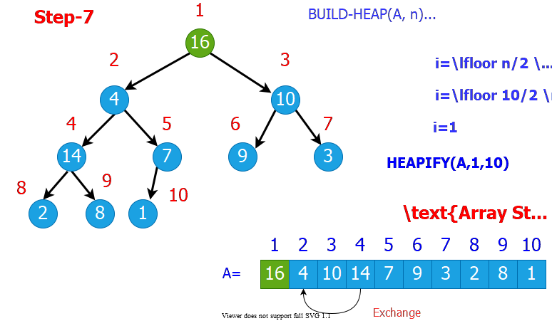

bg right:70% w:800px

## Build-Heap Example (Step-8)

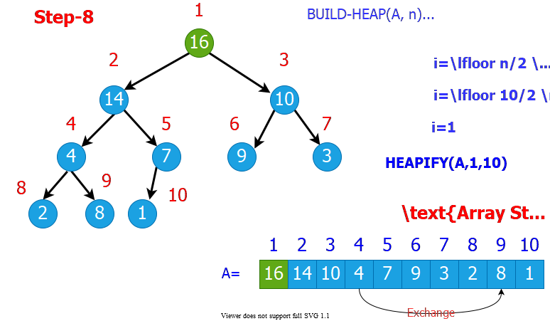

bg right:70% w:800px

## Build-Heap Example (Step-9)

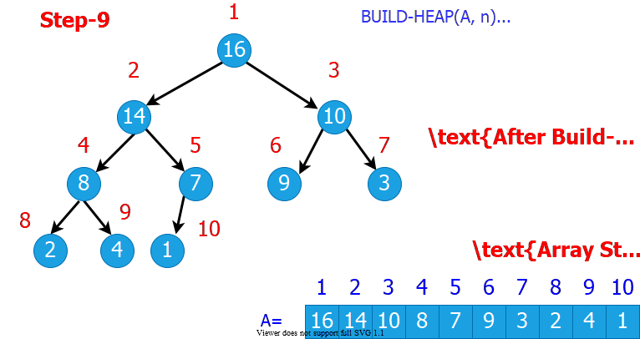

bg right:70% w:800px

## Build-Heap: Runtime Analysis

* Simple analysis:
  + $O\left(n\right)$ calls to $HEAPIFY$, each of which takes $O\left(lgn\right)$ time
  + $O\left(nlgn\right)$ $⇒$ loose bound
* In general, a good approach:
  + Start by proving an easy bound
  + Then, try to tighten it
* Is there a tighter bound?

## Build-Heap: **Tighter** Running Time Analysis

* If the heap is complete binary tree then $h_{ℓ}=d–ℓ$
* Otherwise, nodes at a given level do not all have the same height, But we have $d–ℓ–1≤h_{ℓ}≤d–ℓ$

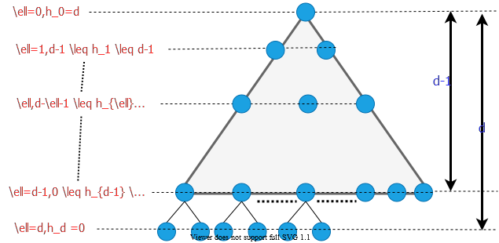

alt:“alt” height:420px center

## Build-Heap: **Tighter** Running Time Analysis

* Assume that all nodes at level $ℓ=d–1$ are processed

$$\begin{matrix}T\left(n\right) & =\sum_{ℓ=0}^{d−1}{n_{ℓ}}O\left(h_{ℓ}\right)=O\left(\sum_{ℓ=0}^{d−1}{n_{ℓ}}h_{ℓ}\right)\left\{\begin{matrix}n_{ℓ}=2^{ℓ}=\#\text{ of nodes at level }ℓ \\ h_{ℓ}=\text{height of nodes at level }ℓ\end{matrix}\right. \\ ∴T\left(n\right) & =O(\sum_{ℓ=0}^{d−1}{2^{ℓ}}\left(d−ℓ\right)) \\ \text{Let } & h=d−ℓ⇒ℓ=d−h\text{ change of variables} \\ T\left(n\right) & =O(\sum_{h=1}^{d}{h}2^{d−h})=O(\sum_{h=1}^{d}{h}\frac{2^{d}}{2^{h}})=O(2^{d}\sum_{h=1}^{d}{h}{\left(1/2\right)}^{h}) \\ \text{ but } & 2^{d}=Θ\left(n\right)⇒O(n\sum_{h=1}^{d}{h}{\left(1/2\right)}^{h})\end{matrix}$$

## Build-Heap: **Tighter** Running Time Analysis

$$\sum_{h=1}^{d}{h}{\left(1/2\right)}^{h}≤\sum_{h=0}^{d}{h}{\left(1/2\right)}^{h}≤\sum_{h=0}^{∞}{h}{\left(1/2\right)}^{h}$$

* recall infinite decreasing geometric series
$$\sum_{k=0}^{∞}{x^{k}}=\frac{1}{1−x}\text{ where }\left|x\right|<1$$

* differentiate both sides

$$\sum_{k=0}^{∞}{k}x^{k−1}=\frac{1}{{\left(1−x\right)}^{2}}$$

## Build-Heap: **Tighter** Running Time Analysis

$$\sum_{k=0}^{∞}{k}x^{k−1}=\frac{1}{{\left(1−x\right)}^{2}}$$

* then, multiply both sides by $x$
$$\sum_{k=0}^{∞}{k}x^{k}=\frac{x}{{\left(1−x\right)}^{2}}$$

* in our case: $x=1/2$ and $k=h$

$$
\therefore \sum \limits_{h=0}^{\infty}h(1/2)^h = \frac{1/2}{(1-(1/2))^2}=2=O(1) \\
\therefore T(n)=O(n\sum \limits_{h=1}^{d}h(1/2)^h)=O(n)
$$

## Heapsort Algorithm Steps

* **(1)** Build a heap on array $A\left[1…n\right]$ by calling $BUILD−HEAP\left(A,n\right)$
* **(2)** The largest element is stored at the root $A\left[1\right]$
  + Put it into its correct final position $A\left[n\right]$ by $A\left[1\right]↔A\left[n\right]$
* **(3)** Discard node $n$ from the heap
* **(4)** Subtrees $\left(S2\&S3\right)$ rooted at children of root remain as heaps, but the new root element may violate the heap property.
  + Make $A\left[1…n−1\right]$ a heap by calling $HEAPIFY\left(A,1,n−1\right)$
* **(5) $n←n−1$**
* **(6)** Repeat steps **(2-4)** until $n=2$

## Heapsort Algorithm Example (Step-1)

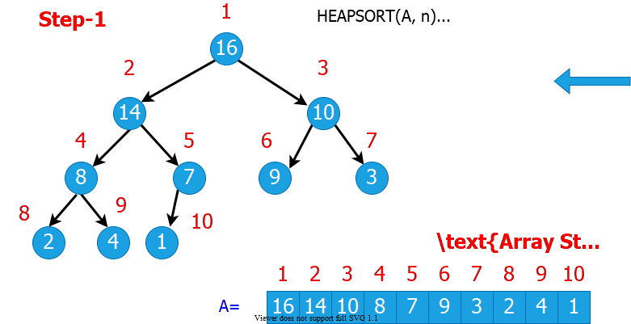

bg right:70% w:800px

## Heapsort Algorithm Example (Step-2)

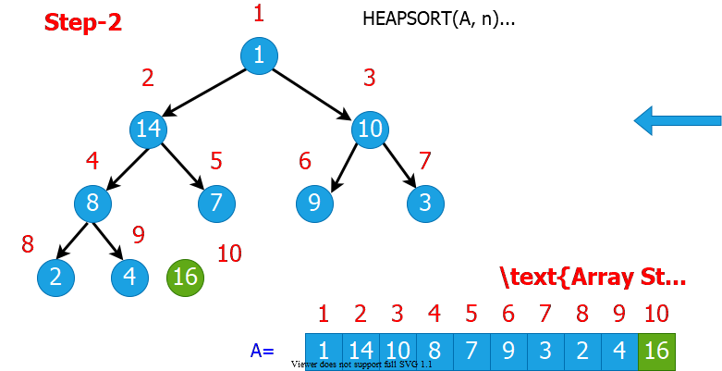

bg right:70% w:800px

## Heapsort Algorithm Example (Step-3)

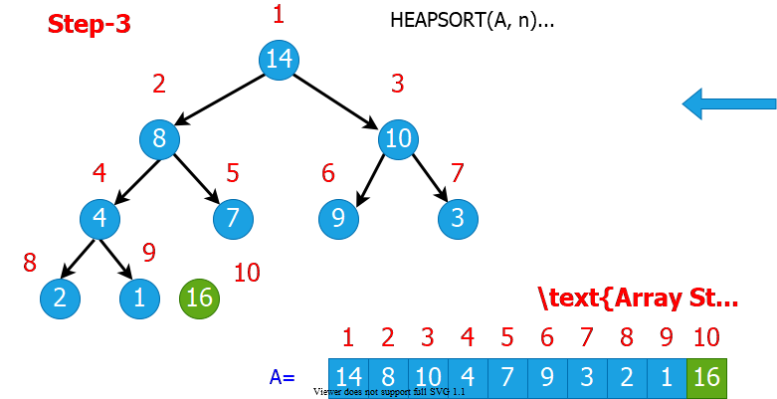

bg right:70% w:800px

## Heapsort Algorithm Example (Step-4)

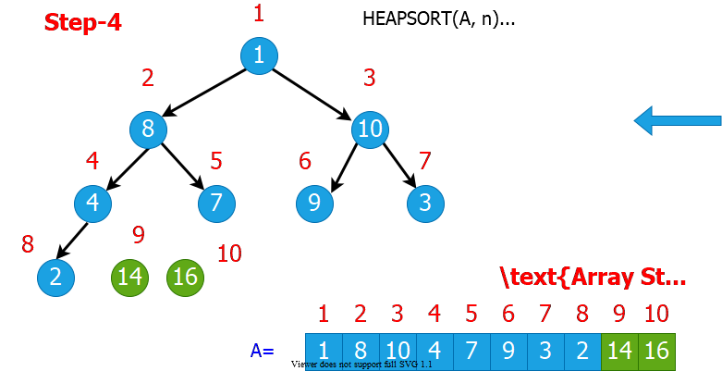

bg right:70% w:800px

## Heapsort Algorithm Example (Step-5)

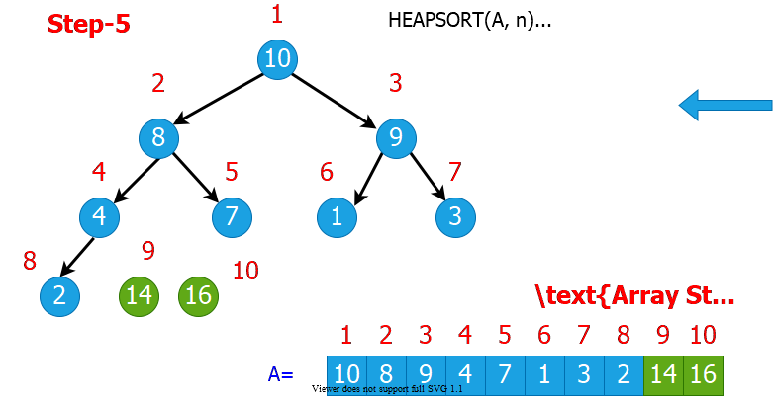

bg right:70% w:800px

## Heapsort Algorithm Example (Step-6)

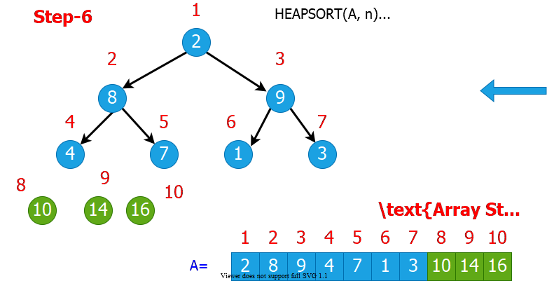

bg right:70% w:800px

## Heapsort Algorithm Example (Step-7)

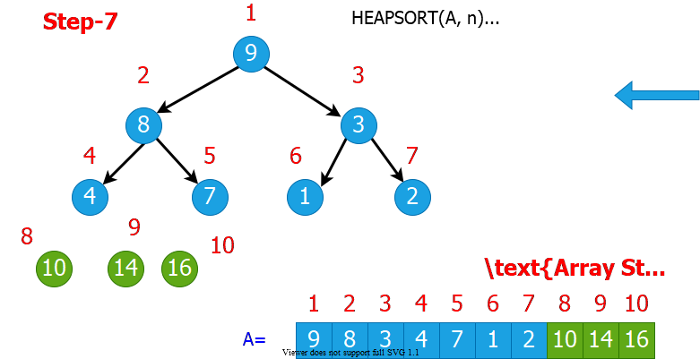

bg right:70% w:800px

## Heapsort Algorithm Example (Step-8)

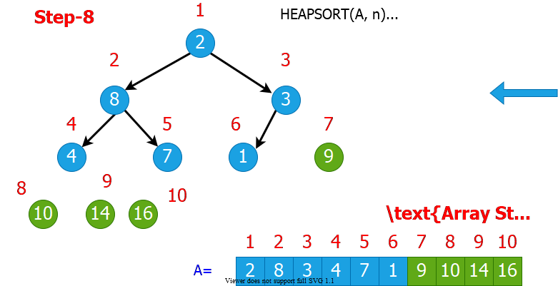

bg right:70% w:800px

## Heapsort Algorithm Example (Step-9)

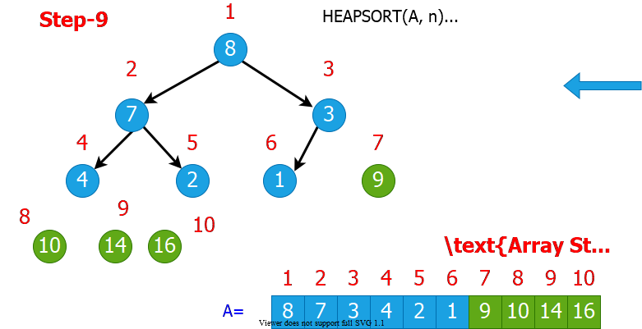

bg right:70% w:800px

## Heapsort Algorithm Example (Step-10)

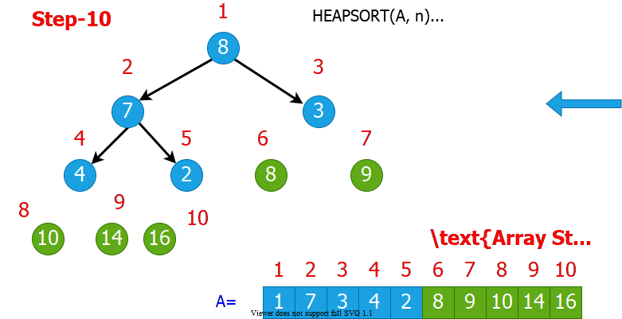

bg right:70% w:800px

## Heapsort Algorithm Example (Step-11)

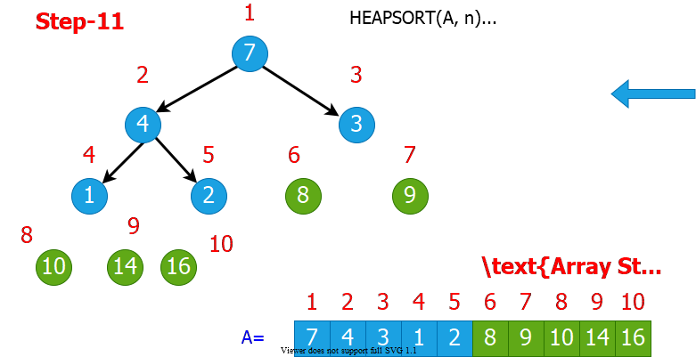

bg right:70% w:800px

## Heapsort Algorithm Example (Step-12)

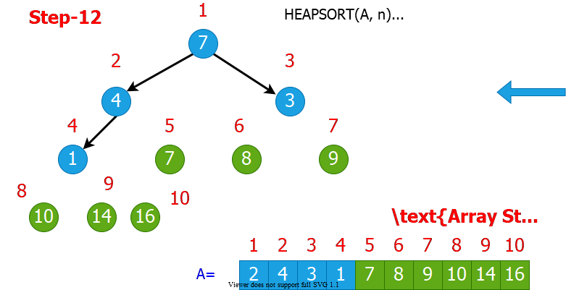

bg right:70% w:800px

## Heapsort Algorithm Example (Step-13)

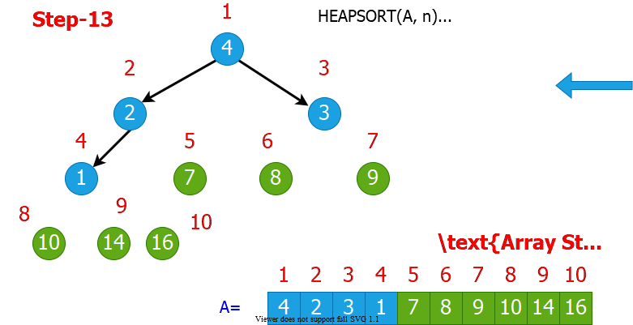

bg right:70% w:800px

## Heapsort Algorithm Example (Step-14)

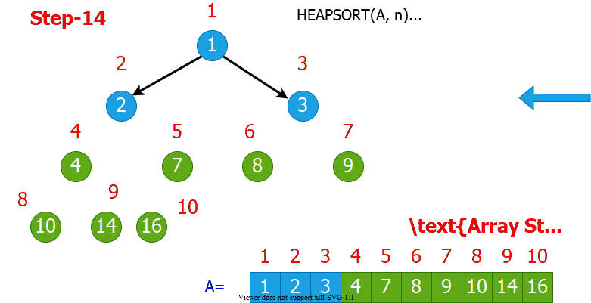

bg right:70% w:800px

## Heapsort Algorithm Example (Step-15)

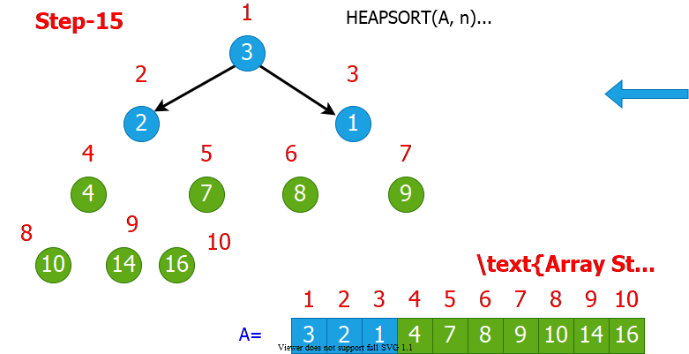

bg right:70% w:800px

## Heapsort Algorithm Example (Step-16)

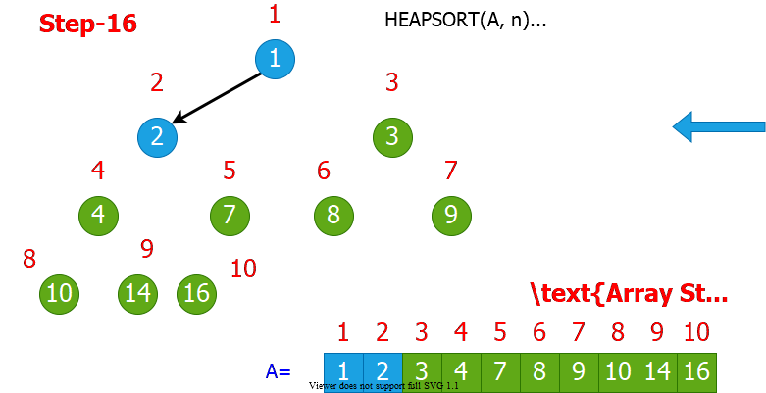

bg right:70% w:800px

## Heapsort Algorithm Example (Step-17)

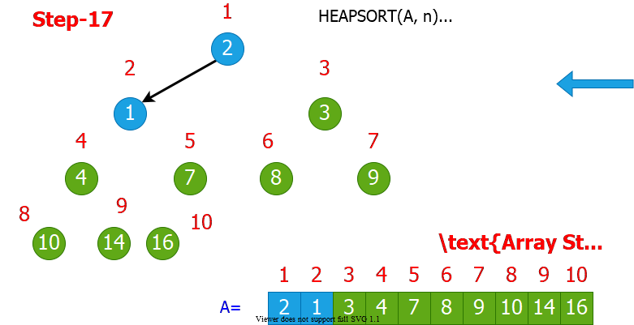

bg right:70% w:800px

## Heapsort Algorithm Example (Step-18)

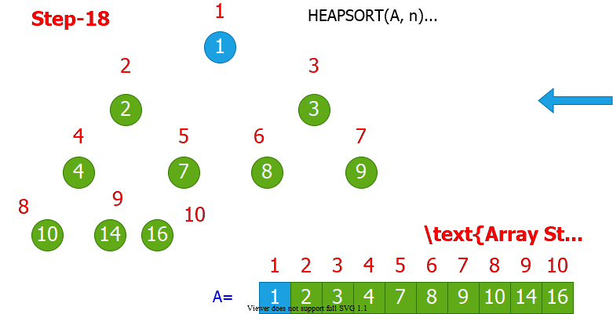

bg right:70% w:800px

## Heapsort Algorithm Example (Step-19)

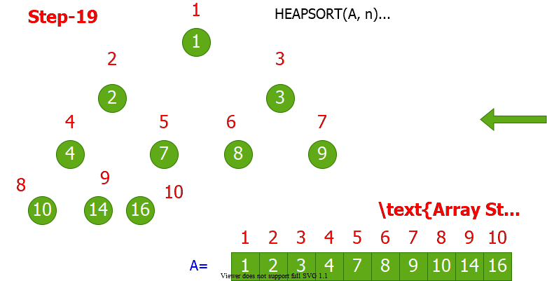

bg right:70% w:800px

## Heapsort Algorithm: Runtime Analysis

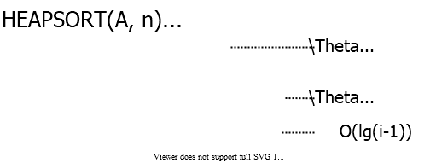

center height:250px

$$\begin{matrix}T\left(n\right) & =Θ\left(n\right)+\sum_{i=2}^{n}{O}\left(lgi\right) \\ & =Θ\left(n\right)+O(\sum_{i=2}^{n}{O}\left(lgn\right)) \\ & =O\left(nlgn\right)\end{matrix}$$

## Heapsort - Notes

* **Heapsort** is a very good algorithm but, a good implementation of **quicksort** always **beats** heapsort **in practice**
* However, **heap data structure** has many popular applications, and it can be efficiently used for implementing **priority queues**

## Data structures for **Dynamic Sets**

* Consider sets of records having **key** and **satellite** data

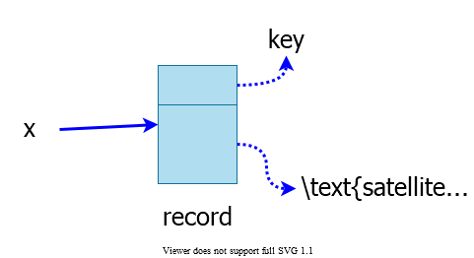

center height:300px

## Operations on **Dynamic Sets**

* **Queries:** Simply return info;
  + $MAX\left(S\right)/MIN\left(S\right):$ (Query) return $x∈S$ with the **largest/smallest $key$**
  + $SEARCH\left(S,k\right):$ (Query) return $x∈S$ with $key\left[x\right]=k$
  + $SUCCESSOR\left(S,x\right)/PREDECESSOR\left(S,x\right):$ (Query) return $y∈S$ which is the next **larger/smaller** element after $x$
* **Modifying operations:** Change the set
  + $INSERT\left(S,x\right):$ (Modifying) $S←S∪\{x\}$
  + $DELETE\left(S,x\right):$ (Modifying) $S←S−\{x\}$
  + $\text{EXTRACT-MAX}\left(S\right)/\text{EXTRACT-MIN}\left(S\right):$ (Modifying) return and delete $x∈S$ with the largest/smallest $key$
* Different data structures support/optimize different operations

## Priority Queues (PQ)

* Supports

$INSERT$

$MAX/MIN$

$\text{EXTRACT-MAX}/\text{EXTRACT-MIN}$

## Priority Queues (PQ)

* **One application:** Schedule jobs on a shared resource
  + **PQ** keeps track of jobs and their relative priorities
  + When a job is finished or interrupted, highest priority job is selected from those pending using $\text{EXTRACT-MAX}$
  + A new job can be added at any time using $INSERT$

## Priority Queues (PQ)

* **Another application:** Event-driven simulation
  + Events to be simulated are the items in the **PQ**
  + Each event is associated with a time of occurrence which serves as a $key$
  + Simulation of an event can cause other events to be simulated in the future
  + Use $\text{EXTRACT-MIN}$ at each step to choose the next event to simulate
  + As new events are produced insert them into the **PQ** using $INSERT$

## Implementation of **Priority Queue**

* **Sorted linked list:** Simplest implementation
  + - time
    - Scan the list to find place and splice in the new item
 $\text{EXTRACT-MAX}$

 $O\left(1\right)$  - time
    - Take the first element
  + **Fast** extraction but **slow** insertion.

## Implementation of **Priority Queue**

* **Unsorted linked list:** Simplest implementation
  + - time
    - Put the new item at front
 $\text{EXTRACT-MAX}$

 $O\left(n\right)$  - time
    - Scan the whole list
  + **Fast** insertion but **slow** extraction.
* Sorted linked list is better on the average
  + **Sorted list:** on the average, scans $n/2$ element per insertion
  + **Unsorted list:** always scans $n$ element at each extraction

## Heap Implementation of **PQ**

* $INSERT$ and $\text{EXTRACT-MAX}$ are both $O\left(lgn\right)$
  + good compromise between fast insertion but slow extraction and vice versa
* $\text{EXTRACT-MAX}$: already discussed $\text{HEAP-EXTRACT-MAX}$
* $INSERT$: Insertion is like that of Insertion-Sort.

HEAP-INSERT(A, key, n)  
 n = n+1  
 i=n   
 while i>1 and A[floor(i/2)] < key do  
 A[i]=A[floor(i/2)]   
 i= floor(i/2)  
 A[i]=key

## Heap Implementation of **PQ**

* Traverses $O\left(lgn\right)$ nodes, as $HEAPIFY$ does but makes fewer comparisons and assignments
  + $HEAPIFY$: compares parent with both children
  + $HEAP−INSERT$: with only one

## HEAP-INSERT Example (Step-1)

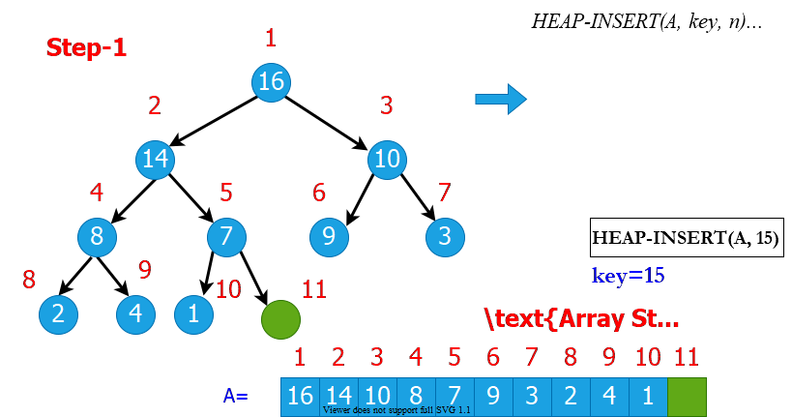

bg right:70% w:800px

## HEAP-INSERT Example (Step-2)

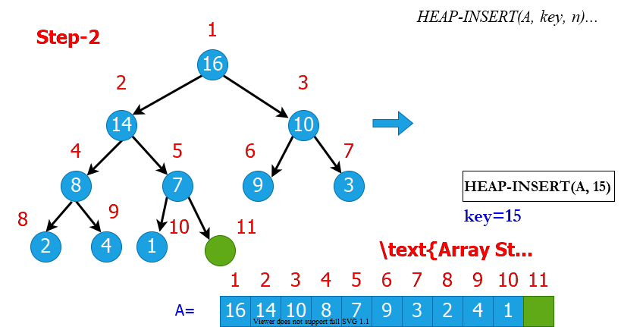

bg right:70% w:800px

## HEAP-INSERT Example (Step-3)

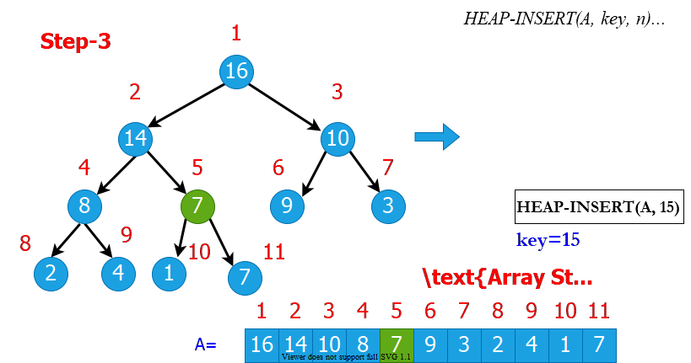

bg right:70% w:800px

## HEAP-INSERT Example (Step-4)

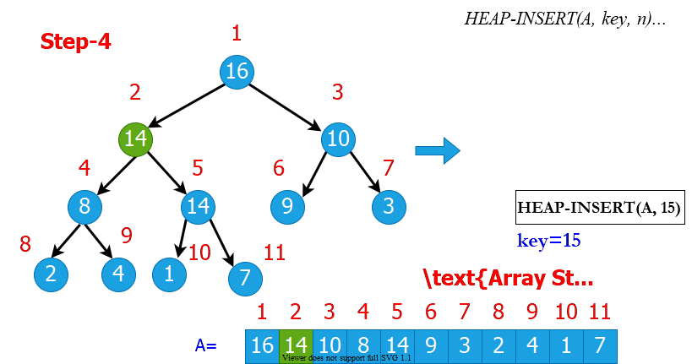

bg right:70% w:800px

## HEAP-INSERT Example (Step-5)

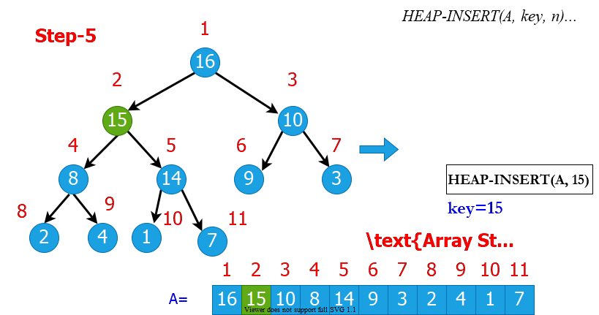

bg right:70% w:800px

## Heap Increase Key

* Key value of $i^{th}$ element of heap is increased from $A\left[i\right]$ to $key$

HEAP-INCREASE-KEY(A, i, key)  
  
 if key < A[i] then  
 return error  
  
 while i > 1 and A[floor(i/2)] < key do  
 A[i] = A[floor(i/2)]   
 i = floor(i/2)  
  
 A[i] = key

## HEAP-INCREASE-KEY Example (Step-1)

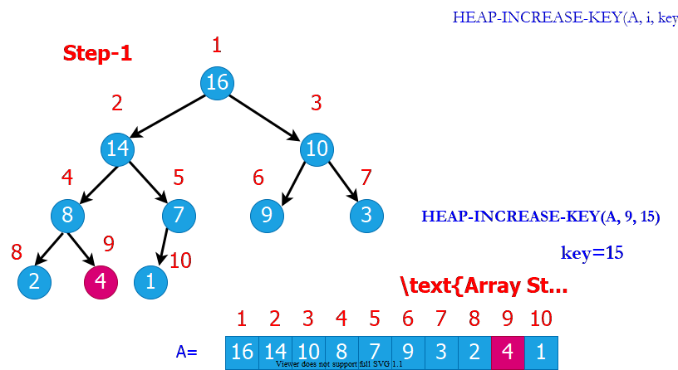

bg right:70% w:800px

## HEAP-INCREASE-KEY Example (Step-2)

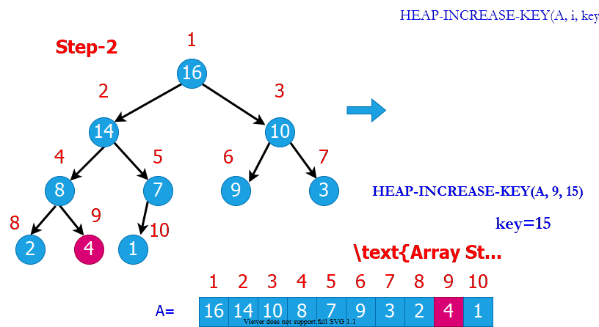

bg right:70% w:800px

## HEAP-INCREASE-KEY Example (Step-3)

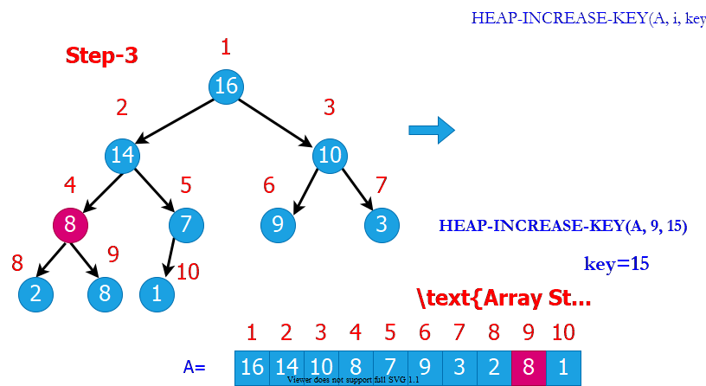

bg right:70% w:800px

## HEAP-INCREASE-KEY Example (Step-4)

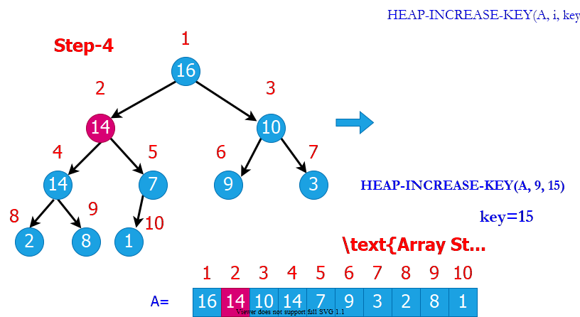

bg right:70% w:800px

## HEAP-INCREASE-KEY Example (Step-5)

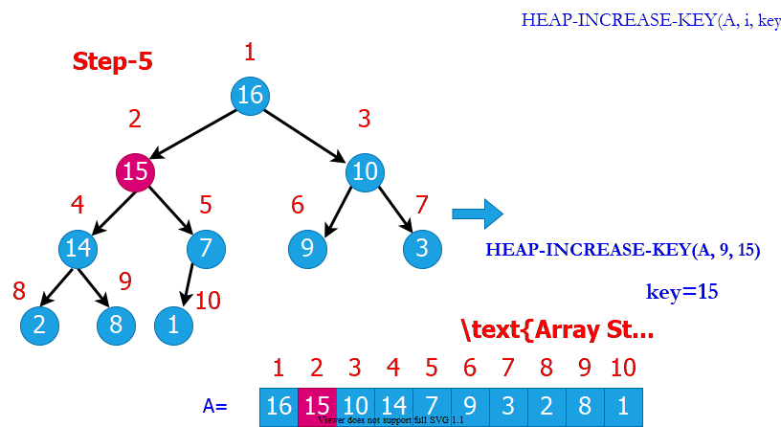

bg right:70% w:800px

## Heap Implementation of Priority Queue (PQ)

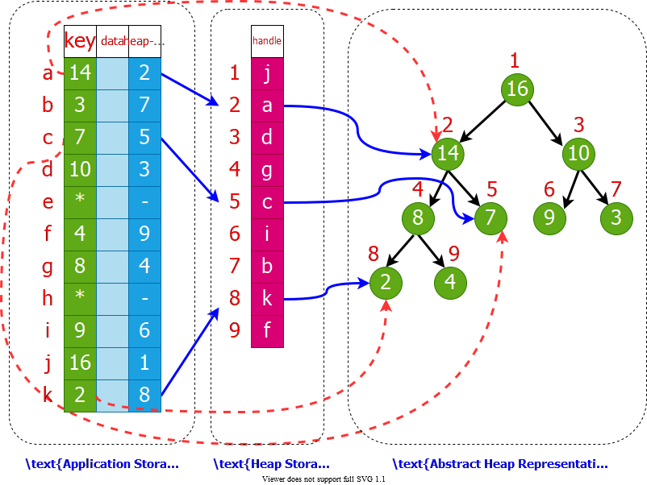

bg right:70% w:800px

## Summary: **Max Heap**

* **Heapify(A, i)**
  + Works when both child subtrees of node i are heaps
  + “*Floats down*” node i to satisfy the heap property
  + Runtime: $O\left(lgn\right)$
* **Max(A, n)**
  + Returns the max element of the heap (no modification)
  + Runtime: $O\left(1\right)$
* **Extract-Max(A, n)**
  + Returns and removes the max element of the heap
  + Fills the gap in $A\left[1\right]$ with $A\left[n\right]$, then calls **Heapify(A,1)**
  + Runtime: $O\left(lgn\right)$

## Summary: **Max Heap**

* **Build-Heap(A, n)**
  + Given an arbitrary array, builds a heap from scratch
  + Runtime: $O\left(n\right)$
* **Min(A, n)**
  + How to return the min element in a max-heap?
  + Worst case runtime: $O\left(n\right)$
    - because ~half of the heap elements are leaf nodes
  + Instead, use a min-heap for efficient min operations
* **Search(A, x)**
  + For an arbitrary $x$ value, the worst-case runtime: $O\left(n\right)$
  + Use a sorted array instead for efficient search operations

## Summary: **Max Heap**

* **Increase-Key(A, i, x)**
  + Increase the key of node $i$ (from $A\left[i\right]$ to $x$)
  + “*Float up*” $x$ until heap property is satisfied
  + Runtime: $O\left(lgn\right)$
* **Decrease-Key(A, i, x)**
  + Decrease the key of node $i$ (from $A\left[i\right]$ to $x$)
  + Call **Heapify(A, i)**
  + Runtime: $O\left(lgn\right)$

## **Phone Operator** Problem

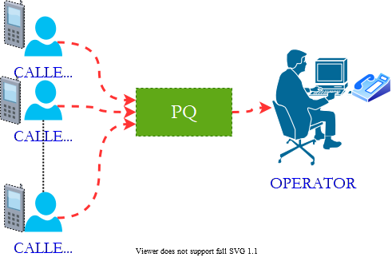

bg right:40% w:500px

* A phone operator answering $n$ **phones**
* Each phone $i$ has $x_{i}$ **people waiting** in line for their calls to be answered.
* Phone operator needs to answer the phone with the largest number of people waiting in line.
* New calls come continuously, and some people hang up after waiting.

## **Phone Operator** Solution

* **Step 1:** Define the following array:
* $A\left[i\right]$: the ith element in heap
* $A\left[i\right].id$: the index of the corresponding phone
* $A\left[i\right].key$: $\#$ of people waiting in line for phone with index $A\left[i\right].id$

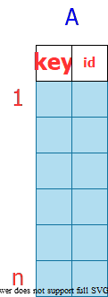

bg right:30% w:200px

## **Phone Operator** Solution

* **Step 2: $\text{Build-Max-Heap}\left(A,n\right)$**
  + **Execution:**
    - When the operator wants to answer a phone:
      * + answer phone with index $id$
      * When a new call comes in to phone i:
 $\text{Increase-Key}\left(A,i,A\left[i\right].key+1\right)$     * When a call drops from phone i:

$\text{Decrease-Key}\left(A,i,A\left[i\right].key−1\right)$

## Linked Lists

* Like arrays, Linked List is a linear data structure.
* Unlike arrays, linked list elements are not stored at a contiguous location; the elements are linked using pointers.

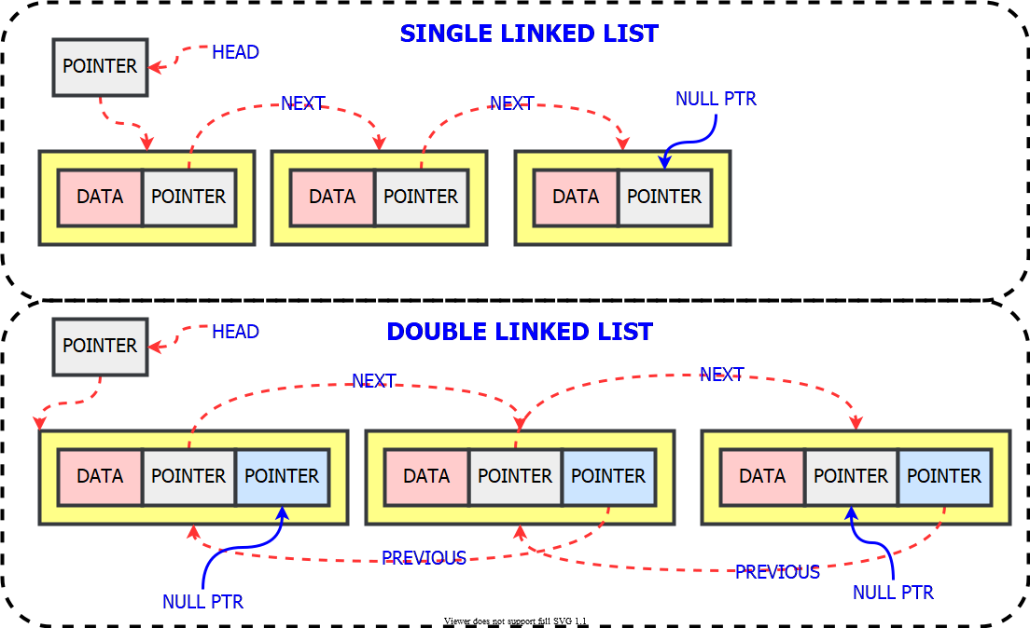

bg right:60% w:730px

## Linked Lists - C Definition

* C
* // A linked list node  
  struct Node {  
   int data;  
   struct Node* next;  
  };

## Linked Lists - Cpp Definition

* Cpp
* class Node {  
  public:  
   int data;  
   Node* next;  
  };

## Linked Lists - Java Definition

* Java
* class LinkedList {  
   Node head; // head of the list  
    
   /* Linked list Node*/  
   class Node {  
   int data;  
   Node next;  
    
   // Constructor to create a new node  
   // Next is by default initialized  
   // as null  
   Node(int d) { data = d; }  
   }  
  }

## Linked Lists - Csharp Definition

* Csharp
* class LinkedList {  
   // The first node(head) of the linked list  
   // Will be an object of type Node (null by default)  
   Node head;  
    
   class Node {  
   int data;  
   Node next;  
    
   // Constructor to create a new node  
   Node(int d) { data = d; }  
   }  
  }

## Priority Queue using **Linked List** Methods

* Implement Priority Queue using Linked Lists.
  + **push():** This function is used to insert a new data into the queue.
  + **pop():** This function removes the element with the highest priority from the queue.
  + **peek()/top():** This function is used to get the highest priority element in the queue without removing it from the queue.

## Priority Queue using **Linked List** Algorithm

PUSH(HEAD, DATA, PRIORITY)  
 Create NEW.Data = DATA & NEW.Priority = PRIORITY  
 If HEAD.priority < NEW.Priority   
 NEW -> NEXT = HEAD  
 HEAD = NEW   
 Else  
 Set TEMP to head of the list   
 Endif  
  
 WHILE TEMP -> NEXT != NULL and TEMP -> NEXT ->PRIORITY > PRIORITY THEN  
 TEMP = TEMP -> NEXT   
 ENDWHILE  
  
 NEW -> NEXT = TEMP -> NEXT   
 TEMP -> NEXT = NEW

## Priority Queue using **Linked List** Algorithm

POP(HEAD)  
//Set the head of the list to the next node in the list.  
HEAD = HEAD -> NEXT.  
Free the node at the head of the list

PEEK(HEAD):   
Return HEAD -> DATA

## Priority Queue using **Linked List** Notes

* LinkedList is already sorted.
* Time Complexities and Comparison with Binary Heap

|  | peek() | push() | pop() |
| --- | --- | --- | --- |
| Linked List | $O\left(1\right)$ | $O\left(n\right)$ | $O\left(1\right)$ |
| Binary Heap | $O\left(1\right)$ | $O\left(lgn\right)$ | $O\left(lgn\right)$ |

## Sorting in Linear Time

## How Fast Can We Sort?

* The algorithms we have seen so far:
  + Based on comparison of elements
  + We only care about the relative ordering between the elements (not the actual values)
  + The smallest worst-case runtime we have seen so far: $O\left(nlgn\right)$
  + Is $O\left(nlgn\right)$ the best we can do?
* **Comparison sorts:** Only use comparisons to determine the relative order of elements.

## Decision Trees for Comparison Sorts

* Represent a sorting algorithm abstractly in terms of a **decision tree**
  + A **binary tree** that represents the **comparisons between** elements in the sorting algorithm
  + Control, data movement, and other aspects are ignored
* One decision tree corresponds to one sorting algorithm and one value of $n$ (*input size*)

## Reminder: Insertion Sort Step-By-Step Description (1)

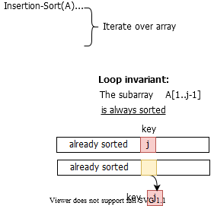

bg right:60% w:700px

## Reminder: Insertion Sort Step-By-Step Description (2)

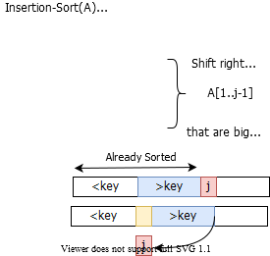

bg right:60% w:700px

## Reminder: Insertion Sort Step-By-Step Description (3)

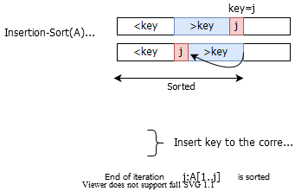

bg right:60% w:700px

## Different Outcomes for Insertion Sort and n=3

* Input : $<a_{1},a_{2},a_{3}>$

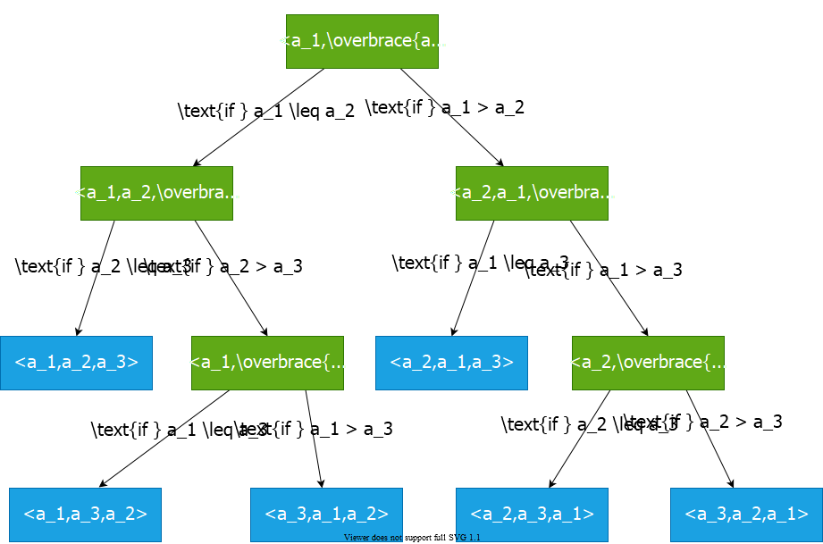

bg right:65% w:760px

## Decision Tree for Insertion Sort and n=3

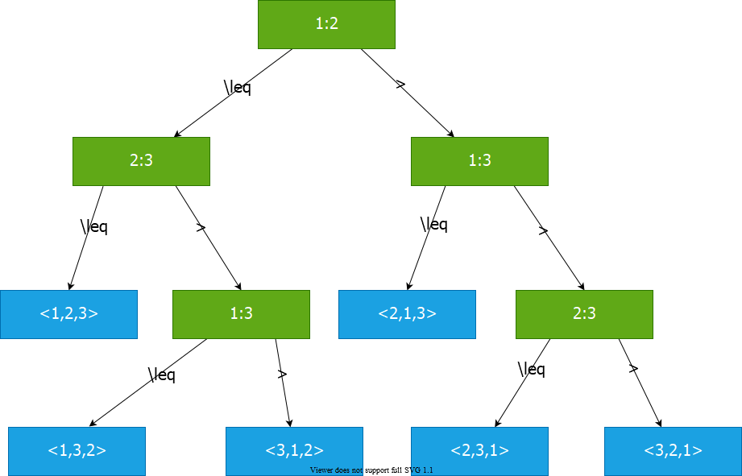

bg right:70% w:850px

## Decision Tree Model for Comparison Sorts

* **Internal node $\left(i:j\right)$:** Comparison between elements $a_{i}$ and $a_{j}$
* **Leaf node:** An output of the sorting algorithm
* **Path from root to a leaf:** The execution of the sorting algorithm for a given input
* **All possible executions** are captured by the decision tree
* **All possible outcomes (permutations)** are in the leaf nodes

## Decision Tree for Insertion Sort and n=3

* Input: $<9,4,6>$

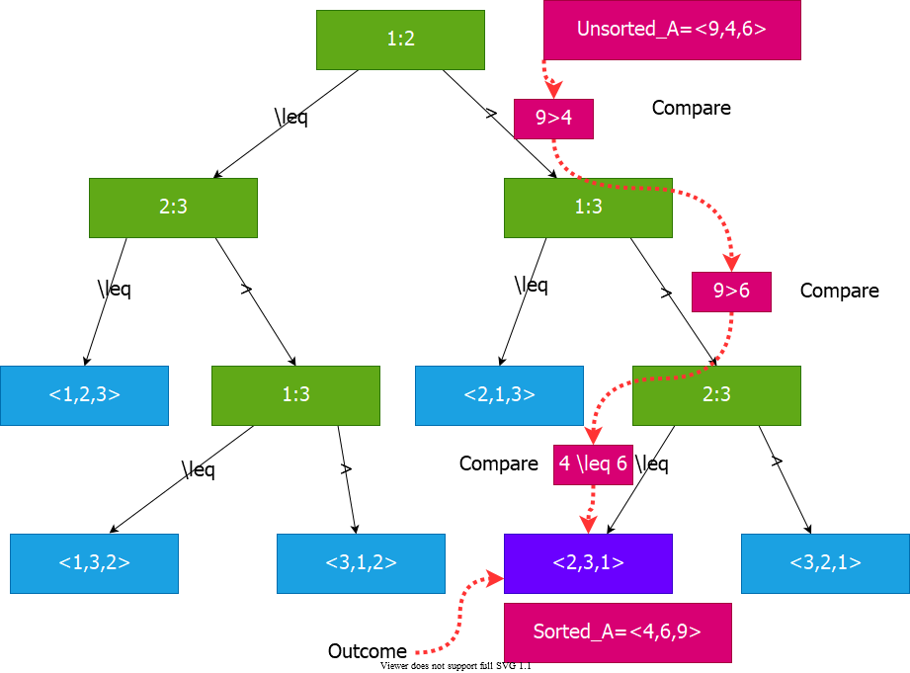

bg right:70% w:850px

## Decision Tree Model

* A decision tree can model the execution of any comparison sort:
  + One tree for each input size $n$
  + View the algorithm as **splitting** whenever it compares two elements
  + The tree contains the **comparisons along all possible** instruction traces
* **The running time of the algorithm $=$** *the length of the path taken*
* **Worst case running time $=$** *height of the tree*

## Counting Sort

## Lower Bound for Comparison Sorts

* Let $n$ be the number of elements in the input array.
* What is the $min$ number of leaves in the decision tree?
  + $n!$**(because there are n! permutations of the input array, and all possible outputs must be captured in the leaves)**
* What is the max number of leaves in a binary tree of height $h$? $⇒$ $2^{h}$
* So, we must have:

$$2^{h}≥n!$$

## Lower Bound for Decision Tree Sorting

* **Theorem:** Any comparison sort algorithm requires $Ω\left(nlgn\right)$ comparisons in the worst case.
* **Proof:** We’ll prove that any decision tree corresponding to a comparison sort algorithm must have height $Ω\left(nlgn\right)$

$$\begin{matrix}2^{h} & ≥n! \\ h & ≥lg\left(n!\right) \\ & ≥lg\left({\left(n/e\right)}^{n}\right)\left(StirlingApproximation\right) \\ & =nlgn−nlge \\ & =Ω\left(nlgn\right)\end{matrix}$$

## Lower Bound for Decision Tree Sorting

**Corollary:** Heapsort and merge sort are asymptotically optimal comparison sorts.

**Proof:** The $O\left(nlgn\right)$ upper bounds on the runtimes for heapsort and merge sort match the $Ω\left(nlgn\right)$**worst-case** lower bound from the previous theorem.

## Sorting in Linear Time

* **Counting sort:** No comparisons between elements
  + **Input: $A\left[1…n\right]$** , where $A\left[j\right]∈\{1,2,…,k\}$
  + **Output: $B\left[1…n\right]$** , sorted
  + **Auxiliary storage: $C\left[1…k\right]$**

## Counting Sort-1

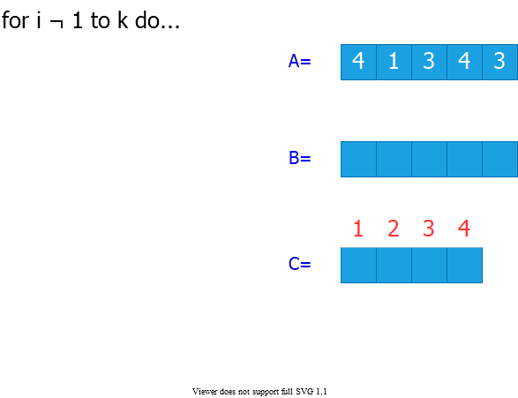

bg right:60% w:750px

## Counting Sort-2

* **Step 1:** Initialize all counts to 0

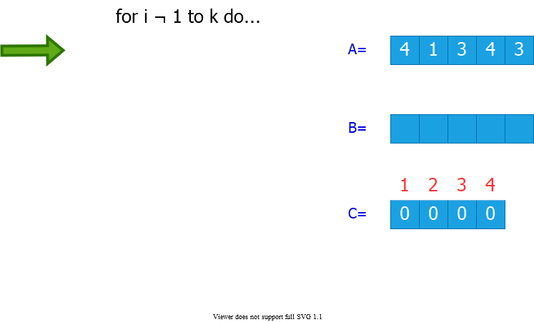

bg right:60% w:750px

## Counting Sort-3

* **Step 2:** Count the number of occurrences of each value in the input array

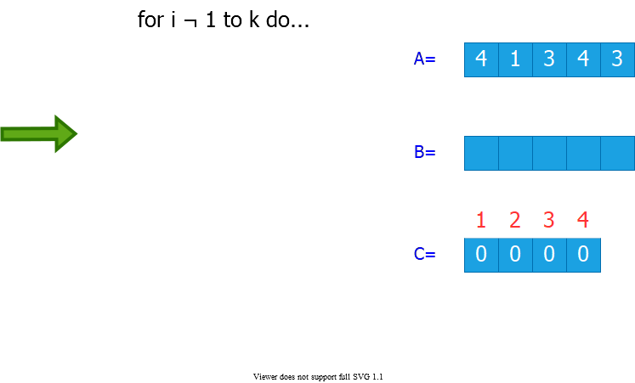

bg right:60% w:750px

## Counting Sort-4

* **Step 3:** Compute the number of elements less than or equal to each value

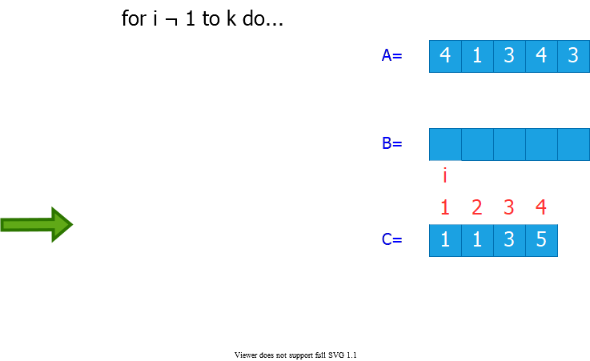

bg right:60% w:750px

## Counting Sort-5

* **Step 4:** Populate the output array
  + There are $C\left[3\right]=3$ elements that are $≤3$

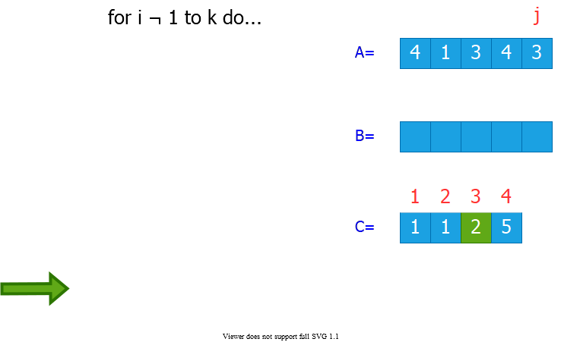

bg right:60% w:750px

## Counting Sort-6

* **Step 4:** Populate the output array
  + There are $C\left[4\right]=5$ elements that are $≤4$

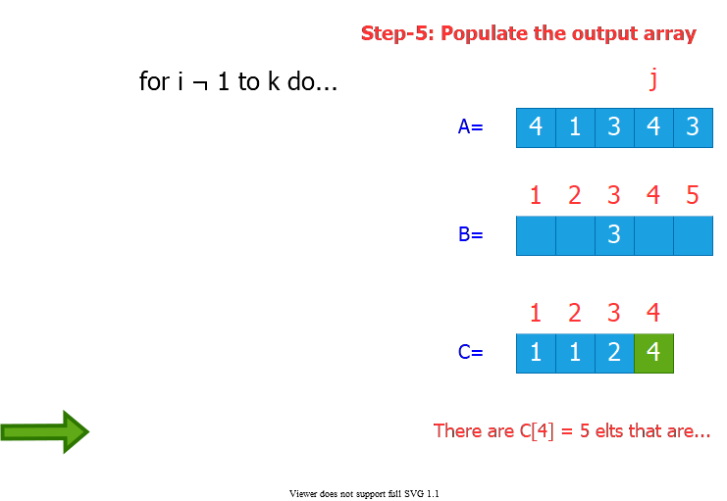

bg right:60% w:750px

## Counting Sort-7

* **Step 4:** Populate the output array
  + There are $C\left[3\right]=2$ elements that are $≤3$

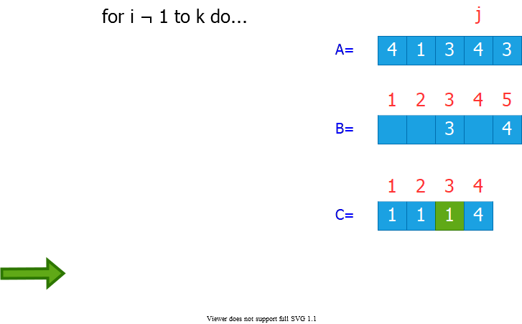

bg right:60% w:750px

## Counting Sort-8

* **Step 4:** Populate the output array
  + There are $C\left[1\right]=1$ elements that are $≤1$

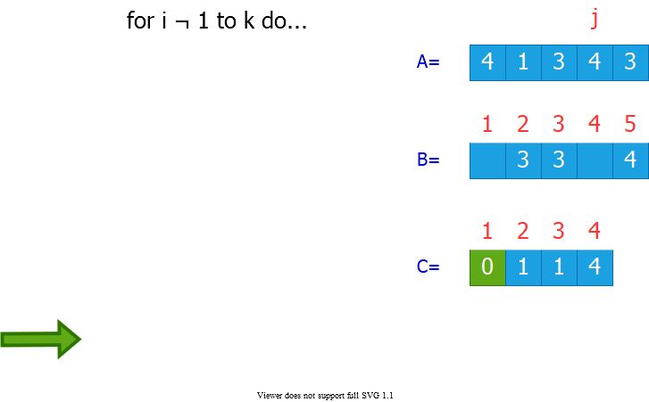

bg right:60% w:750px

## Counting Sort-9

* **Step 4:** Populate the output array
  + There are $C\left[4\right]=4$ elements that are $≤4$

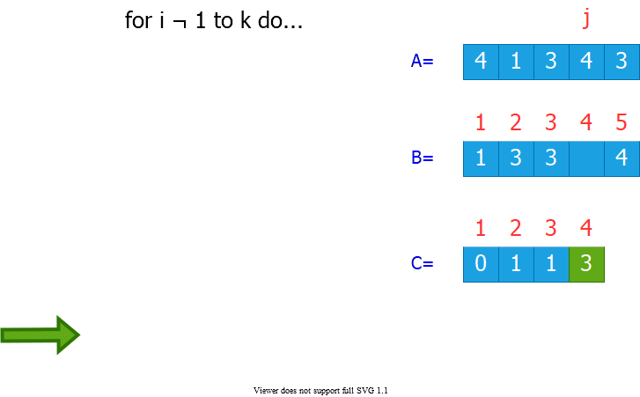

bg right:60% w:750px

## Counting Sort: Runtime Analysis

* **Total Runtime: $Θ\left(n+k\right)$**
  + $n$: size of the input array
  + $k$: the range of input values

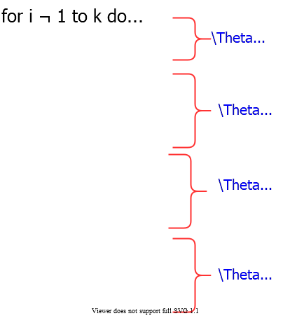

bg right:60% w:550px

## Counting Sort: Runtime

* Runtime is $Θ\left(n+k\right)$
  + If $k=O\left(n\right)$, then counting sort takes $Θ\left(n\right)$
* **Question:** We proved a lower bound of $Θ\left(nlgn\right)$ before! Where is the fallacy?
* **Answer:**
  + $Θ\left(nlgn\right)$ lower bound is for comparison-based sorting
  + Counting sort is not a comparison sort
  + In fact, not a single comparison between elements occurs!

## Stable Sorting

* Counting sort is a **stable sort:** It preserves the input order among equal elements.
  + i.e. The numbers with the same value appear in the output array in the same order as they do in the input array.
* **Note**: Which other sorting algorithms have this property?

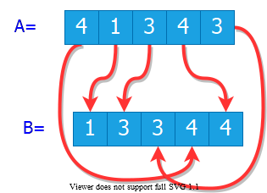

center h:300px

## Radix Sort

* **Origin:** Herman Hollerith’s card-sorting machine for the 1890 US Census.
* **Basic idea:** Digit-by-digit sorting
* Two variations:
  + Sort from **MSD** to **LSD** (bad idea)
  + Sort from **LSD** to **MSD** (good idea)

(*LSD/MSD: Least/most significant digit*)

## Herman Hollerith (1860-1929)

* The 1880 U.S. Census took **almost 10 years** to process.
* While a lecturer at MIT, Hollerith prototyped **punched-card technology**.
* His machines, including a **card sorter**, allowed the 1890 census total to be reported in **6 weeks**.
* He founded the **Tabulating Machine Company** in 1911, which merged with other companies in 1924 to form **International Business Machines(IBM)**.

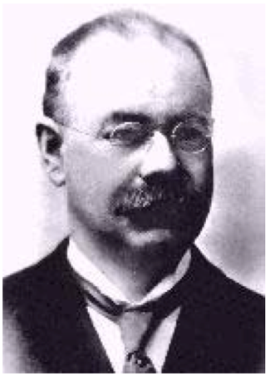

center h:250px

## Hollerith Punched Card

* **Punched card:** A piece of stiff paper that contains digital information represented by the presence or absence of holes.
  + 12 rows and 24 columns
  + coded for age, state of residency, gender, etc.

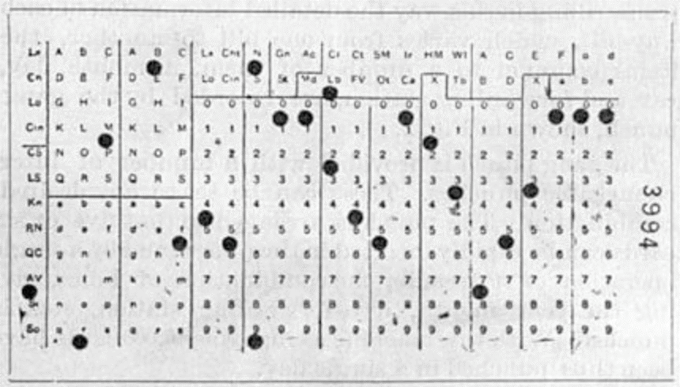

center h:300px

## **Modern** IBM card

* One character per column
  + So, that’s why text windows have 80 columns!
* 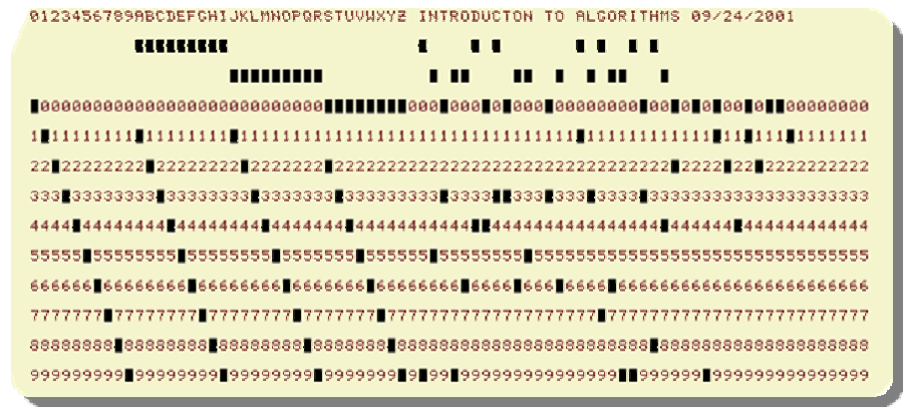
* center h:350px
* for more samples visit https://en.wikipedia.org/wiki/Punched_card

## Hollerith Tabulating Machine and Sorter

* Mechanically sorts the cards based on the hole locations.
* Sorting performed for one column at a time
* Human operator needed to load/retrieve/move cards at each stage

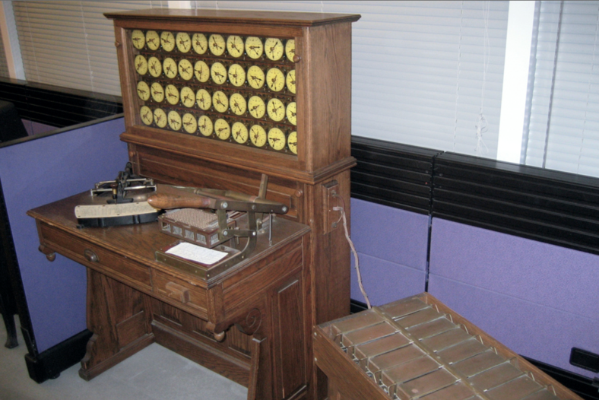

center h:350px

## Hollerith’s MSD-First Radix Sort

* Sort starting from the most significant digit (MSD)
* Then, sort each of the resulting bins recursively
* At the end, combine the decks in order

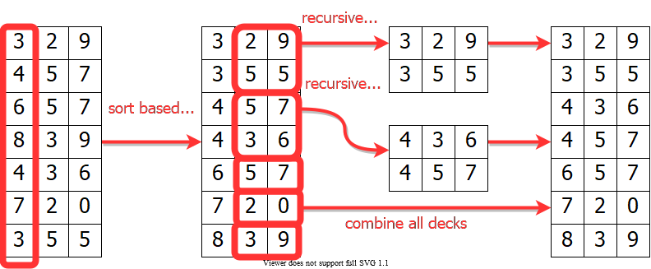

center h:350px

## Hollerith’s MSD-First Radix Sort

* To sort a subset of cards recursively:
  + All the other cards need to be removed from the machine, because the machine can handle only one sorting problem at a time.
  + The human operator needs to keep track of the intermediate card piles
* 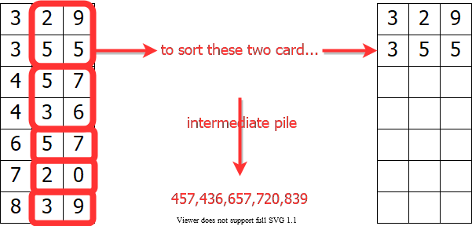
* center h:300px

## Hollerith’s MSD-First Radix Sort

* MSD-first sorting may require:
  + very large number of sorting passes
  + very large number of intermediate card piles to maintain
* **S(d):**
  + $\#$ of passes needed to sort d-digit numbers (worst-case)
* **Recurrence:**
  + $S\left(d\right)=10S\left(d−1\right)+1$ with $S\left(1\right)=1$
    - **Reminder:** Recursive call made to each subset with the same most significant digit(MSD)

## Hollerith’s MSD-First Radix Sort

* **Recurrence: $S\left(d\right)=10S\left(d−1\right)+1$**
$$\begin{matrix}S\left(d\right) & =10S\left(d−1\right)+1 \\ & =10(10S\left(d−2\right)+1)+1 \\ & =10(10(10S\left(d−3\right)+1)+1)+1 \\ & =10iS\left(d−i\right)+10i−1+10i−2+…+101+100 \\ & =\sum_{i=0}^{d−1}{{10}^{i}}\end{matrix}$$

* Iteration terminates when $i=d−1$ with $S\left(d−\left(d−1\right)\right)=S\left(1\right)=1$

## Hollerith’s MSD-First Radix Sort

* **Recurrence: $S\left(d\right)=10S\left(d−1\right)+1$**

$$\begin{matrix}S\left(d\right) & =\sum_{i=0}^{d−1}{{10}^{i}} \\ & =\frac{{10}^{d}−1}{10−1} \\ & =\frac{1}{9}\left({10}^{d}−1\right) \\ & ⇓ \\ S\left(d\right) & =\frac{1}{9}\left({10}^{d}−1\right)\end{matrix}$$

## Hollerith’s MSD-First Radix Sort

* $P\left(d\right)$: $\#$ of intermediate card piles maintained (worst-case)
* **Reminder:** Each routing pass generates 9 intermediate piles except the sorting passes on least significant digits (LSDs)
  + There are ${10}^{d−1}$ sorting calls to LSDs

$$\begin{matrix}P\left(d\right) & =9\left(S\left(d\right)–{10}^{d−1}\right) \\ & =9\frac{\left({10}^{d–1}\right)}{9–{10}^{d−1}} \\ & =\left({10}^{d–1}–9*{10}^{d−1}\right) \\ & ={10}^{d−1}−1\end{matrix}$$

## Hollerith’s MSD-First Radix Sort

$$\begin{matrix}P\left(d\right) & ={10}^{d−1}−1\end{matrix}$$

**Alternative solution:** Solve the recurrence

$$\begin{matrix}P\left(d\right) & =10P\left(d−1\right)+9 \\ P\left(1\right) & =0\end{matrix}$$

## Hollerith’s MSD-First Radix Sort

* **Example:** To sort $3$ digit numbers, in the worst case:
  + $S\left(d\right)=\left(1/9\right)\left(103−1\right)=111$ sorting passes needed
  + $P\left(d\right)=10d−1−1=99$ intermediate card piles generated
* MSD-first approach has more recursive calls and intermediate storage requirement
  + Expensive for a **tabulating machine** to sort punched cards
  + Overhead of recursive calls in a modern computer

## LSD-First Radix Sort

* Least significant digit (**LSD**)-first radix sort seems to be a folk invention originated by machine operators.
* It is the counter-intuitive, but the better algorithm.
* **Basic Algorithm:**
* Sort numbers on their LSD first (Stable Sorting Needed)  
  Combine the cards into a single deck in order   
  Continue this sorting process for the other digits  
   from the LSD to MSD
* Requires only $d$ sorting passes
* No intermediate card pile generated

## LSD-first Radix Sort **Example**

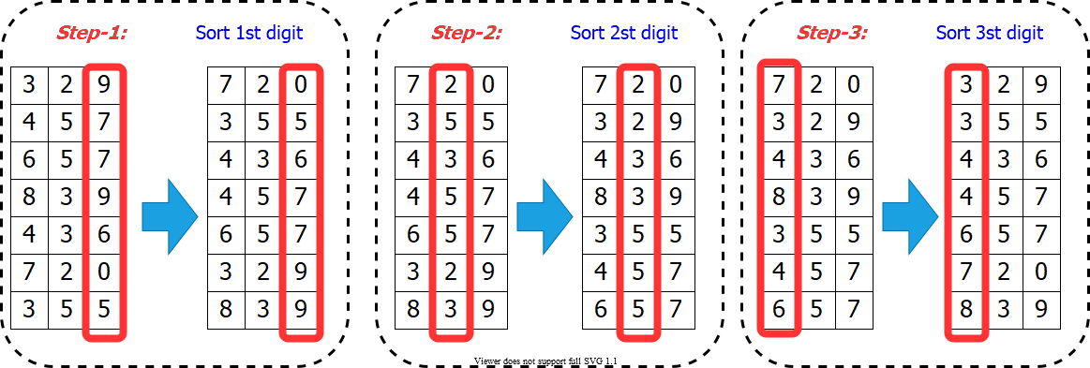

center h:500px

## Correctness of Radix Sort **(LSD-first)**

* **Proof by induction:**
  + **Base case: $d=1$** is correct (**trivial**)
  + **Inductive hyp:** Assume the first $d−1$ digits are sorted correctly
* Prove that all $d$ digits are sorted correctly after sorting digit $d$
* Two numbers that differ in digit $d$ are correctly sorted (**e.g. 355 and 657**)
* Two numbers equal in digit d are put in the same order as the input
  + (**correct order**)

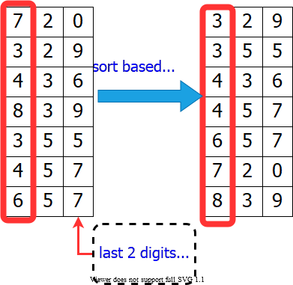

bg right:39% h:450px

## Radix Sort **Runtime**

* Use counting-sort to sort each digit
* **Reminder:** Counting sort complexity: $Θ\left(n+k\right)$
  + $n$: size of input array
  + $k$: the range of the values
* Radix sort runtime: $Θ\left(d\left(n+k\right)\right)$
  + $d$: $\#$ of digits

**How to choose the $d$ and $k$?**

## Radix Sort: Runtime – **Example 1**

* We have flexibility in choosing $d$ and $k$
* Assume we are trying to sort **32-bit words**
  + We can define each digit to be **4 bits**
  + Then, the range for each digit $k=2^{4}=16$
    - So, counting sort will take $Θ\left(n+16\right)$
  + The number of digits $d=32/4=8$
  + Radix sort runtime: $Θ\left(8\left(n+16\right)\right)=Θ\left(n\right)$

$\overset{\text{32-bits}}{\overbrace{\left[4bits\left|4bits\right|4bits\left|4bits\right|4bits\left|4bits\right|4bits|4bits\right]}}$

## Radix Sort: Runtime – **Example 2**

* We have flexibility in choosing $d$ and $k$
* Assume we are trying to sort **32-bit words**
  + Or, we can define each digit to be **8 bits**
  + Then, the range for each digit $k=2^{8}=256$
    - So, counting sort will take $Θ\left(n+256\right)$
  + The number of digits $d=32/8=4$
  + Radix sort runtime: $Θ\left(4\left(n+256\right)\right)=Θ\left(n\right)$

$\overset{\text{32-bits}}{\overbrace{\left[8bits\left|8bits\right|8bits|8bits\right]}}$

## Radix Sort: **Runtime**

* Assume we are trying to sort $b$**-bit** words
  + Define each digit to be $r$ **bits**
  + Then, the range for each digit $k=2^{r}$
    - So, **counting sort will take $Θ\left(n+2^{r}\right)$**
  + The number of digits $d=b/r$
    - **Radix sort runtime:**

$$\begin{matrix}T\left(n,b\right) & =Θ(\frac{b}{r}\left(n+2^{r}\right))\end{matrix}$$

$\overset{b/r\text{ bits}}{\overbrace{\left[rbits\left|rbits\right|rbits|rbits\right]}}$

## Radix Sort: **Runtime Analysis**

$$\begin{matrix}T\left(n,b\right) & =Θ(\frac{b}{r}\left(n+2^{r}\right))\end{matrix}$$

* Minimize $T\left(n,b\right)$ by differentiating and setting to $0$
* Or, intuitively:
  + We want to balance the terms $\left(b/r\right)$ and $\left(n+2^{r}\right)$
  + **Choose $r≈lgn$** 
    - If we choose $r<<lgn⇒\left(n+2^{r}\right)$ term **doesn’t improve**
    - If we choose $r>>lgn⇒\left(n+2^{r}\right)$ increases **exponentially**

## Radix Sort: **Runtime Analysis**

$$\begin{matrix}T\left(n,b\right) & =Θ(\frac{b}{r}\left(n+2^{r}\right))\end{matrix}$$

$$\begin{matrix}\text{Choose }r=lgn⇒T\left(n,b\right)=Θ\left(bn/lgn\right)\end{matrix}$$

* For numbers in the range from $0$ to $n^{d}–1$, we have:
  + The number of bits $b=lg\left(nd\right)=dlgn$
    - Radix sort runs in $Θ\left(dn\right)$

## Radix Sort: **Conclusions**

$$\begin{matrix}\text{Choose }r=lgn⇒T\left(n,b\right)=Θ\left(bn/lgn\right)\end{matrix}$$

* **Example:** Compare radix sort with merge sort/heapsort
  + $1$ million ($2^{20}$), $32$-bit numbers $\left(n=2^{20},b=32\right)$
    - **Radix sort: $⌊32/20⌋=2$** passes
    - **Merge sort/heap sort: $lgn=20$** passes
* **Downsides:**
  + Radix sort has **little locality of reference** (more cache misses)
  + The version that uses counting sort is not in-place
* On modern processors, a well-tuned quicksort implementation typically runs faster.

## References

* [Introduction to Algorithms, Third Edition | The MIT Press](https://mitpress.mit.edu/books/introduction-algorithms-third-edition)
* [Bilkent CS473 Course Notes (new)](http://nabil.abubaker.bilkent.edu.tr/473/)
* [Bilkent CS473 Course Notes (old)](http://cs.bilkent.edu.tr/~ugur/teaching/cs473/)
* [Insertion Sort - GeeksforGeeks](https://www.geeksforgeeks.org/insertion-sort/)
* [Priority Queue Using Linked List - GeeksforGeeks](https://www.geeksforgeeks.org/priority-queue-using-linked-list/)
* [Priority Queue Using Linked List - JavatPoint](https://www.javatpoint.com/priority-queue-using-linked-list)
* [NIST Dictionary of Algorithms and Data Structures](https://xlinux.nist.gov/dads/)
* [NIST - Dictionary of Algorithms and Data Structures](https://xlinux.nist.gov/dads/)

$−End−Of−Week−4−Course−Module−$